
Institute of Information Technology
Jahangirnagar University, Savar, Dhaka-1342

Lab Report - 02
Lab Title: Linux File Commands (File Management & Directory Management)

Course Code: ICT-3102
Course Title: Operating System Lab

Submitted by:
Md. Shaon Khan
Id: 1984
Batch: 52 Batch
Session: 2022-2023

Supervised by:
Mehrin Anannya
Assistant Professor, Institute of Information Technology
Jahangirnagar University

Date: April 27, 2026

1. Objective

In this lab, we practiced frequently used Linux commands for file and directory management. The goal was to get comfortable with the Linux terminal by running real commands and observing what each one does. We learned how to list files, navigate directories, create and delete files, and view file contents.

2. Theory

Linux is a command-line-based operating system where most operations are done through a terminal. Unlike graphical interfaces, the terminal gives more control over the system. In this lab, we used the Ubuntu terminal to run various file management commands.

Linux treats everything as a file including directories. Commands like ls, cd, mkdir, cat, touch, and rm are fundamental tools every Linux user needs to know. These commands are simple but very powerful when combined together.

We also learned that Linux uses a tree-like file structure starting from the root (/). Each user has a home directory (e.g., /home/shaon) and this is where we worked throughout the lab.

3. Commands Used
Command | Description
ls | Lists all files and directories in the current folder.
ls -al | Shows a detailed list including hidden files (files starting with a dot).
ls -lt | Lists files sorted by modification time, newest first.
cd <dir> | Changes the current directory to the specified one.
cd - | Goes back to the previously visited directory.
cd .. | Moves up one level to the parent directory.
cd | Goes directly to the home directory.
pwd | Prints the full path of the current working directory.
mkdir <dir> | Creates a new directory with the given name.
cat > <file> | Creates a new file and lets the user type content into it.
echo "text" >> <file> | Appends a line of text to an existing file.
more <file> | Shows the file content page by page.
head <file> | Displays the first 10 lines of a file.
tail <file> | Displays the last 10 lines of a file.
touch <file> | Creates an empty file or updates the timestamp of an existing file.
clear | Clears the terminal screen.
rm <file> | Deletes the specified file.
rm -r <dir> | Deletes a directory along with everything inside it.
rm -f <file> | Force deletes a file without asking for confirmation.
rm -rf <dir> | Force deletes a directory and all its contents recursively.

4. Procedure
We opened the terminal on Ubuntu and ran each command one by one. For every command, we first ran it, then observed the output and noted what happened. Below is a step-by-step description of what we did.

4.1 ls Directory Listing
Lists all non-hidden files and folders in the current directory.
Command:
$ ls
Output:
Desktop Documents Downloads Music Pictures Projects Public snap Templates Videos
We saw all the directories inside the home folder. Hidden files were not visible with plain ls.

4.2 ls -al Detailed Listing with Hidden Files
Shows a detailed list including file permissions, owner, size, date, and hidden files.
Command:
$ ls -al
Output:
total 88
drwxr-x--- 17 shaon shaon 4096 Apr 22 20:31 .
-rw------- 1 shaon shaon 1510 Apr 22 20:29 .bash_history
... (and more files including hidden ones starting with .)
We noticed that hidden files like .bashrc, .bash_history, and .profile appeared here but not in the plain ls output.

4.3 ls -lt Sort by Modification Time
Lists files and directories sorted by last modified time, newest first.
Command:
$ ls -lt
Output:
total 40
drwxr-xr-x 2 shaon shaon 4096 Apr 22 20:31 Downloads
drwxrwxr-x 2 shaon shaon 4096 Apr 15 14:45 Projects
...

The Downloads folder appeared at the top because it was modified most recently. This is useful when you need to quickly find recently changed files.

4.4 cd Change Directory
Changes the working directory to the specified folder.
$ cd Documents
$ cd - (back to previous)
$ cd .. (go up one level)
$ cd (go to home)
Output:
/home/shaon
We moved into Documents, then used cd - to go back to where we were. The cd .. moved us up one level. Just typing cd brought us back home instantly.

4.5 pwd Print Working Directory
Displays the full path of the current directory.
Command:
$ pwd
Output:
/home/shaon
This was helpful when we were not sure which directory we were currently in. It always shows the absolute path.

4.6 mkdir Make Directory
Creates a new directory with the given name.
Command:
$ mkdir Projects
Output:
mkdlr: cannot create directory 'Projects': File exists (if already exists)
Otherwise, no output — directory is created silently.
When we tried to create Projects again, it gave an error saying it already exists. Linux does not overwrite existing directories with mkdir.

4.7 cat > file Create File with Input
Creates a new file and allows typing content directly from keyboard. Press Ctrl+D to save.
Command:
$ cat > notes.txt
Hello, This is test file,
created by Shaon Khan
Who are dreamer
want success and try to work hard.
[Ctrl+D]
Output:
(File notes.txt is created with the typed content)
We typed multiple lines and pressed Ctrl+D to finish. The file was saved immediately. We then used cat notes.txt to verify the content.

4.8 echo >> Append to File
Appends a new line of text to an existing file without overwriting it.
Command:
$ echo "This is new line which appends at the last of previous text" >> notes.txt
Output:
(No output — text is appended silently to notes.txt)
After running this, we used more notes.txt to see that the new text was added at the end of the existing content.

4.9 more View File Page by Page
Displays file content one screen at a time. Press Space to continue, q to quit.
Command:
$ more notes.txt
Output:
Hello, This is test file,
created by Shaon Khan
Who are dreamer
want success and try to work hard.This is new line...
The more command was useful when the file was long. It showed content page by page, which was easier to read than cat.

4.10 head First 10 Lines
Prints the first 10 lines of the file.
Command:
$ head notes.txt
Output:
Hello, This is test file,
created by Shaon Khan
Who are dreamer
want success and try to work hard.This is new line...
(first 10 lines shown)
The head command is handy when a file is very large and we only need to check what is at the beginning.

4.11 tail Last 10 Lines
Prints the last 10 lines of the file.
Command:
$ tail notes.txt
Output:
10
11
12
13
14
14
15
16
17
18
The tail command showed the final 10 lines. We used it after adding many numbered lines to the file using echo -e.

4.12 touch Create Empty File
Creates an empty file. If the file already exists, it updates its timestamp.
Command:
$ touch hello.txt
Output:
(No output — hello.txt is created empty)
We used ls after touch to confirm the file was created. The file was empty, which we verified with cat hello.txt.

4.13 rm Remove File
Deletes the specified file permanently.
Command:
$ rm hello.txt
Output:
(No output — file is deleted)
After running rm, we did ls again and confirmed hello.txt was gone. There is no trash or undo in Linux, so we need to be careful with rm.

4.14 rm -r Remove Directory
Deletes a directory and all its contents recursively.
Command:
$ rm -r Projects
Output:
rm: cannot remove 'Projects': No such file or directory (if already removed)
Otherwise removes silently.
We first tried to remove Projects while we were inside it, which gave an error. After going up (cd), it worked correctly.

4.15 rm -f Force Delete File
Force deletes a file without any confirmation prompt.
Command:
$ rm -f notes.txt
Output:
(No output — file deleted without asking)
Unlike rm, this does not prompt at all. It is useful when you want to remove write-protected files quickly.

4.16 rm -rf Force Delete Directory
Force deletes a directory and all its contents without any prompts.
Command:
$ rm -rf Pro
Output:
(No output — directory and all its contents deleted)
This command is very powerful and dangerous. We created a test directory Pro, then removed it completely in one command.

4.17 clear Clear the Terminal
Clears all previous output from the terminal screen.
Command:
$ clear
Output:
(Terminal screen is cleared)
After running many commands, the screen was cluttered. The clear command made it clean again. The command history was still accessible with the up arrow key.

5. Discussion

In this lab, we ran 18 different Linux commands and observed how each one works. A few things stood out to us during the session.

First, we noticed that ls and ls -al show very different results. The plain ls command only shows visible files, while ls -al reveals hidden configuration files like .bashrc and .bash_history. These hidden files are important for system settings.

Second, we learned that the >> operator appends text to a file without overwriting it, while > overwrites. This is an important distinction — using the wrong one can delete existing content.

Third, the rm command is permanent in Linux. There is no recycle bin. So we had to be careful, especially with rm -rf, which deletes everything in a directory silently.

We also noticed that echo -e allows us to use escape characters like \n for newlines. When we added multiple numbered lines to notes.txt, we could then verify them using head and tail commands, which are very efficient for checking large files.

Overall, this lab helped us understand how the Linux terminal handles files and directories. The commands are simple but require careful usage.

6. Conclusion
We successfully completed Lab 2 of the Operating System Lab course. In this session, we practiced all the fundamental Linux file and directory management commands. We created files, wrote content, appended data, viewed files in different ways, and removed files and directories.

Through this lab, we gained practical experience with the Linux terminal. We now feel more confident using the command line for everyday file operations. The knowledge gained here will be helpful for more advanced Linux and OS topics in future labs.

7. Lab Screenshots

The following screenshots were captured during the lab session and show the actual terminal output for the commands we ran.

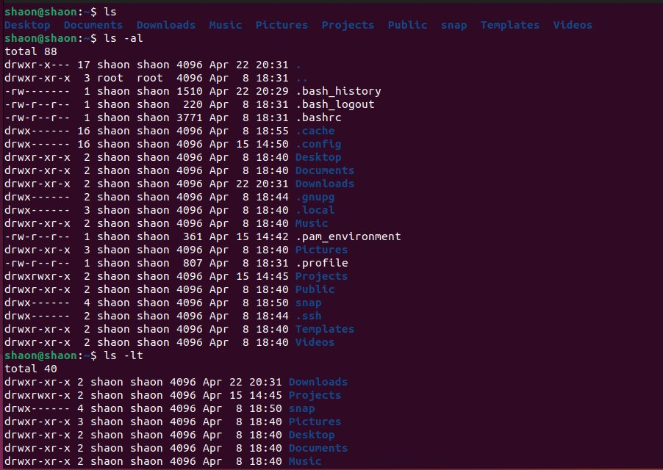
Screenshot 1: ls and ls -al commands showing directory listing and hidden files

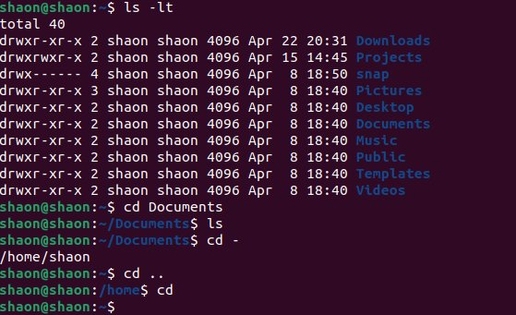
Screenshot 2: ls -lt and cd commands sorted listing and directory navigation
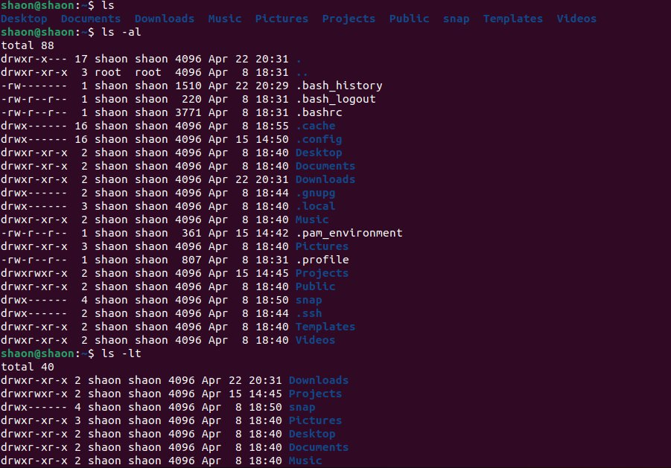
Screenshot 3: ls -al and ls -lt command outputs

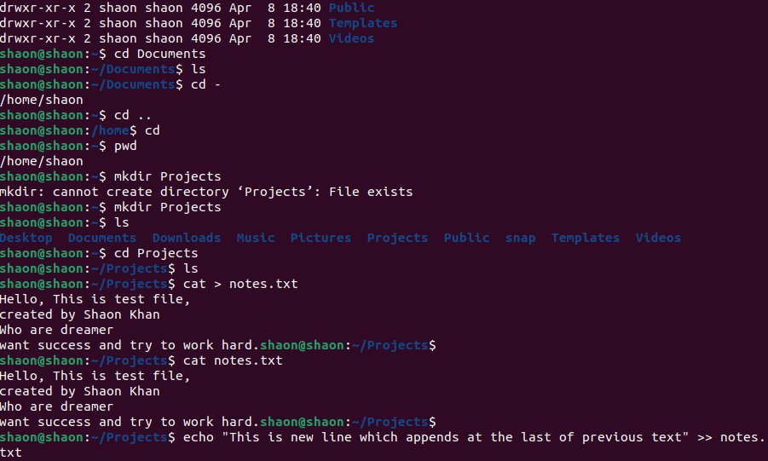
Screenshot 4: mkdir, cd, cat > notes.txt creating directory and writing file
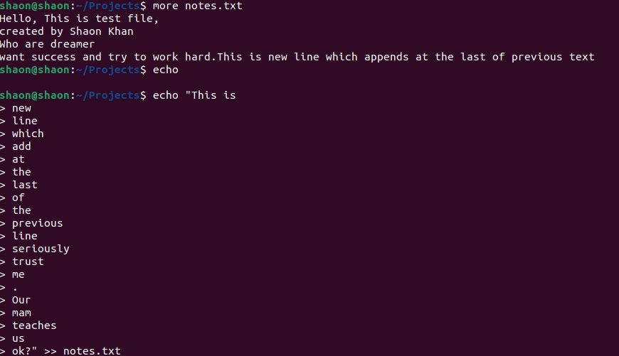
Screenshot 5: more notes.txt and echo append using multi-line input

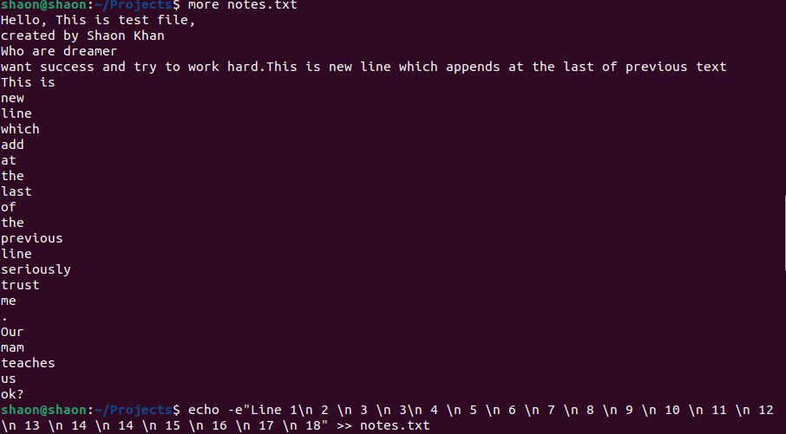
Screenshot 6: more notes.txt showing appended content, and echo -e command
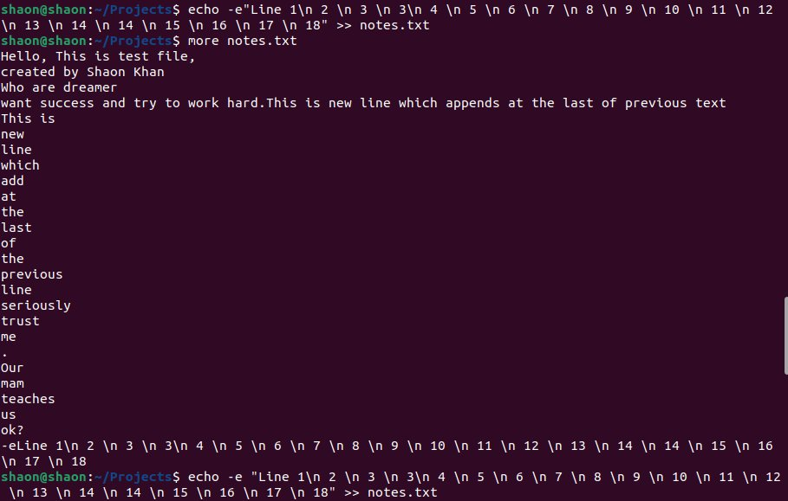
Screenshot 7: echo -e output with multiple numbered lines added to notes.txt

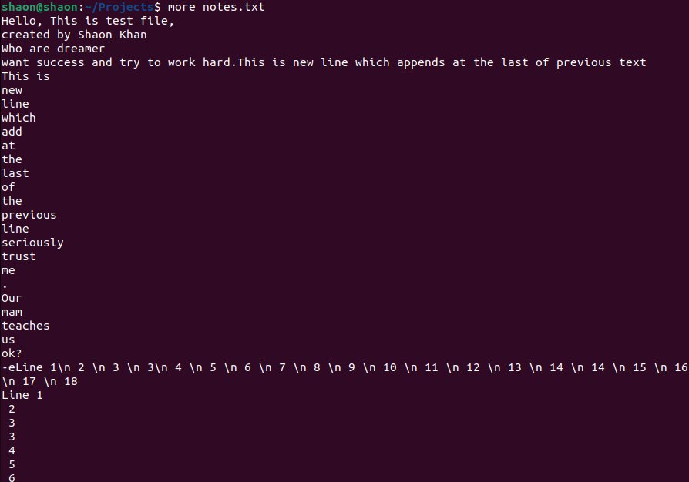
Screenshot 8: more notes.txt showing all content including numbered lines

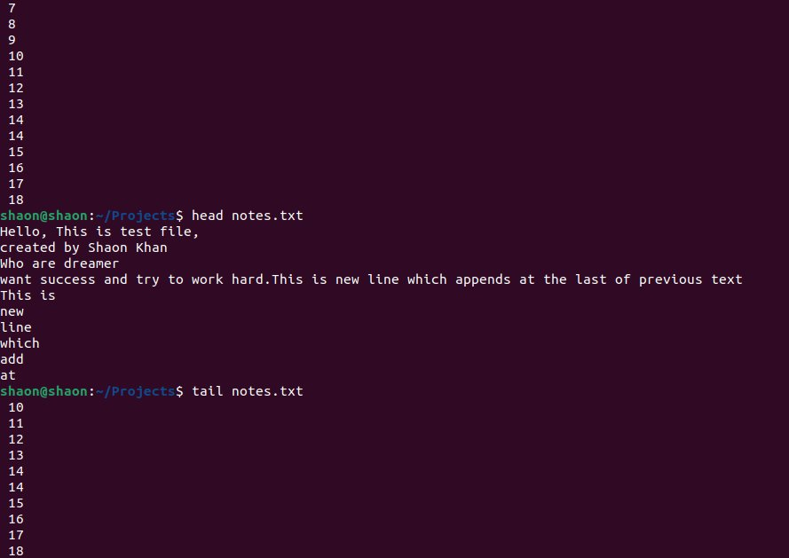
Screenshot 9: Continuation of notes.txt, head and tail commands

Screenshot 10: touch hello.txt creating an empty file

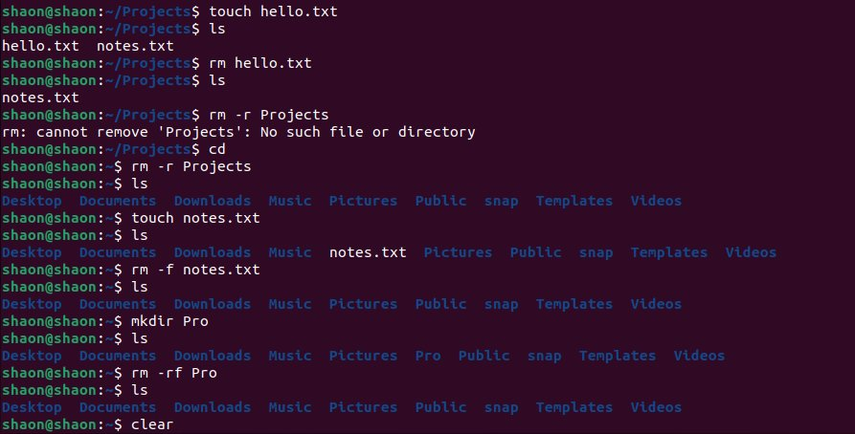
Screenshot 11: rm, rm -r, rm -f, rm -rf, and clear commands

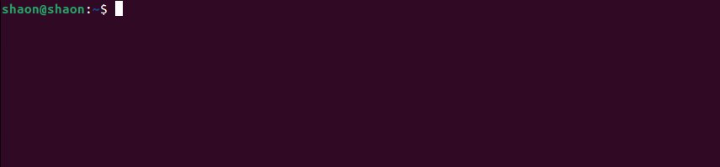
Screenshot 12: Terminal after clear command — clean screen

